**An Open Educational Resource (OER) Learning Management System for Sustainability and Environment Studies**

Digital Media Design Capstone

Masters of Liberal Arts Degree

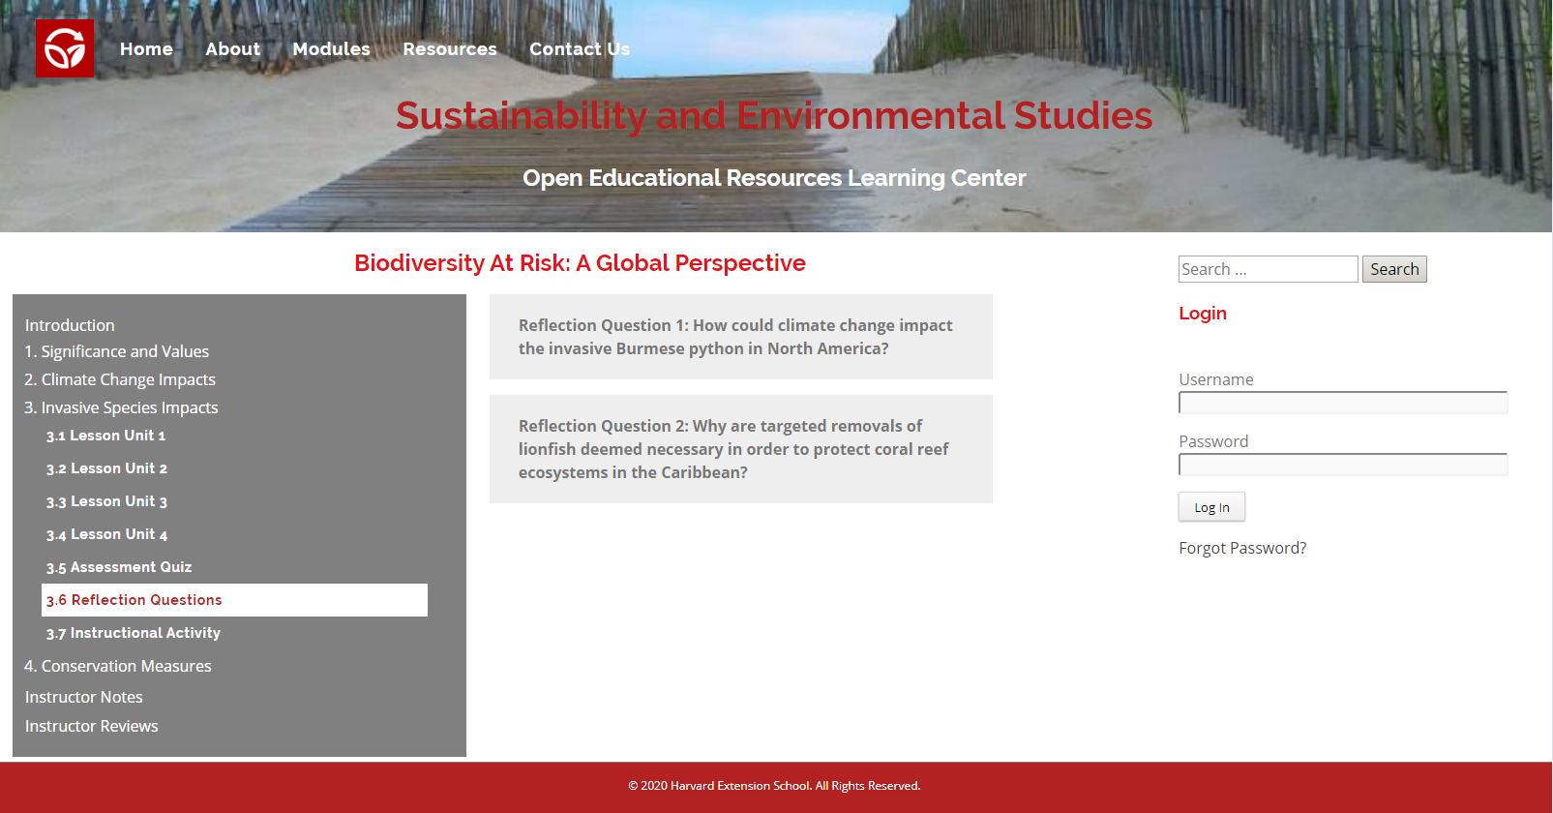

Harvard University

Extension School

May 6, 2020

John F. Reilly

**Table of Contents**

Abstract 1

1. Introduction 2

2. Technology Components….. 2

3. Technology Requirements and Workflow….. 4

4. Prototype Development 7

5. Work Plan and Milestones 8

6. Building the Learning Management System 9

7. Demonstrative Product 11

8. Final Product 16

9. Summary and Conclusions 16

10. Future Plans 17

11. Project Repository 18

References .18

**Abstract**

Notes to Write-up:

. Identity problem with existing on-line education

. LMS purpose to fill this gap

. Summarize assessment criteria to build the LMS

. Summarize conclusions

**1. Introduction**

The fundamental purpose of the Learning Management System (LMS) is to bridge the gap between existing eLearning resources which are often too general and not focused on what environmental students need to learn in order to achieve the desired educational outcomes. Since students are more likely to use an e-Learning platform if it was initially assigned, instructors in Sustainability and Environmental Studies, then, are the primary target audience for the LMS who would wish to supplement their own teachings with the learning modules. The instructional content is not supposed to be introductory or replace textbooks and lectures, but rather to complement instructor teachings by delving deeper into Sustainability and Environmental Studies topics and issues. The LMS further differs from existing eLearning offerings by using an Understanding by Design approach advocated by Grant Wiggins and Jay McTighe. Key principles of this approach include using hooks, chunking, and repetition, having a big idea, addressing misunderstandings, and promoting enduring understandings (Wiggins and McTighe, 2005).

**2. Technology Components**

The Learning Management System was developed as an eLearning website using the WordPress content management system, custom CSS, custom JavaScript, and several WordPress plugins.

**2.1 WordPress Content Management System**

WordPress is a popular content management system which includes a database, a template system, and a plugin architecture. WordPress provides many of the required features of the LMS as well as a built-in database to house the instructional content. A key feature of the LMS is the ability of instructors to edit content with only basic knowledge of the content management system. WordPress was the best content management choice due to its popularity and user-friendliness.

**2.2 Custom CSS**

CSS programming along with JavaScript was needed to tailor the user experience of the WordPress platform into the custom LMS needed to meet the project requirements.

**2.3. Custom JavaScript**

Custom JavaScript programming was required to develop the more advanced features of the LMS such as a collapsible menu system and a responsive design which would be very difficult to achieve solely through the limited capabilities of the included features in WordPress.

**2.4. WordPress Plugins**

WordPress plugins are small software applications which can extend the functionality of WordPress. The following plugins were used for this Capstone project:

|  |  |
| --- | --- |
| **WordPress Plugin** | **LMS Application** |
| BackWPup | Backup WordPress Instance |
| Code Embed | Embed JavaScript and HTML code in posts and pages |
| Contact Form 7 | Create Custom Contact Forms |
| Duplicate Page | Duplicate Posts, Pages and Custom Posts |
| Embed Google Map | Create Google Maps |
| HD Quiz | Create Assessment Quizzes |
| Header and Footer Scripts | Embed JavaScript Coding into Header and Footer |
| PDF Embedder | Embed PDF into Posts and Pages |
| Sidebar Login Widget | Create Sidebar Used to Log into the LMS |
| User Access Manager | Manage Access to Posts, Pages, Categories and Files |

**3. Technology Requirements and Workflow**

HTML5 Blank was selected as the active WordPress theme for the Learning Management System. This minimalistic theme allowed the user experience to be fully realized with the addition of custom CSS and JavaScript programming as well as a few key WordPress Plugins. As an eLearning application, the LMS required the customary pages of a professional educational website. Here is the website map:

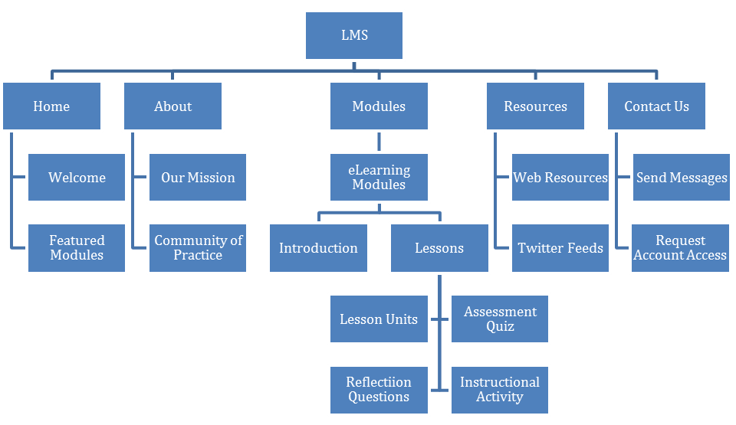

With the instructional content being maintained in a WordPress database, instructors will be able to easily create their own learning modules, lessons, or activities with only basic WordPress knowledge. The instructional design of the LMS will adhere to an Understanding by Design approach. The key Understanding by Design techniques deployed include using hooks, chunking, and repetition, having a big idea, addressing misunderstandings, and promoting enduring understandings (Wiggins and McTighe, 2005).

**Understanding by Design Approach**

|  |  |
| --- | --- |
| High-Level Overview. Briefly describe your learning experience, including the type of learning experience, intended audience, duration, etc. Use the Instructional Design Mad Lib to assist you. | |
| The LMS will offer Sustainability and Environmental Studies eLearning modules to instructors who wish to supplement their own teachings. The instructional content will be curated using an Understanding By Design approach. | |
| Content Topic: Identify the content topic that will be explored. Though broad, this is often where instructional designers begin. | Big Idea: Keep in mind the misunderstanding or gap, and identify the big idea, a ***concept*** about this topic that is worth knowing and can be applied to other content/contexts. It provides a unifying and thoughtful way to focus the design of the project. The big idea should be expressed in a few words. |
| Open Educational Resources for students in Sustainability and Environmental Studies | Align eLearning resources for students in Sustainability and Environmental Studies. |
| Misunderstanding or Gap: Think about the prior experiences, knowledge, and mindset of the learners. What might they misunderstand about this topic or what is a gap in their thinking/experience that prevents them from understanding this topic and/or big idea? This may be informed by any combination of research, observation, or interviewing. | |
| Existing eLearning resources are too general and do not hone in on what students need to learn. | |

|  |  |
| --- | --- |
| 6 Facets of Understanding: The 6 facets are a tool to help unpack what deep learning looks like. Not all facets are applicable for all projects; however, consider each one. What could a possible desired understanding or learning outcome be through the lens of each of the six facets? Share your notes here. | |
| Explanation: Really gets at explaining something in the learner’s own words  Students will understand how short, interactive lessons can be more engaging than text based assignments. | Perspective: Gets at what it means to see the big picture or consider various points of view  Students will understand how interactive learning allows students to learn at their own pace. |
| Interpretation: How to make sense of something  Students will understand that there are multiple ways to learn the same skill. | Empathy: Asks the learner to “walk in another’s shoes”  Students will understand that one way of learning may be more effective for some students than others. |
| Application: Matches knowledge to context  Students will understand how eLearning resources can provide better access to suitable web resources. | Self-Knowledge: Gets learners to think about their own thinking  Students will understand that they learn better when they are more focused and engaged. |
| Why/Enduring Understanding(s): Frame your big idea as 1–2 understanding statements. The understanding statement is expressed as a full-sentence statement and represents an insight, inference, or conclusion about the big idea that learners should gain. Rather than the facts you want them to learn, the understanding statement looks to the meaning of the facts. | |
| Students will understand that Open Educational Resources can be aligned to match their needs in Sustainability and Environmental Studies. | |

|  |
| --- |
| Evidence of Understanding: How will you know that your learners have obtained the desired understanding? This is often thought of as assessment in formal learning environments. For self-paced and informal learning experiences, this may be more difficult to identify but try. |
| The LMS will provide assessment quizzes and reflection questions as well as instructional activities for collaborative problem solving. |

|  |
| --- |
| Learning Flow: What is the general flow of the learning experience? You may provide a bulleted high-level list, create a Journey Map (a timeline that graphically maps the experience), or other graphic organizer. |
| The LMS will offer instructional learning modules to supplement instructor teachings. Each module will comprise of an introduction to capture the student’s attention and several lessons reinforcing the big idea and helping to achieve enduring understandings. Each lesson with be comprised of lesson units, an assessment quiz, reflective questions, and an instructional activity. |

|  |  |
| --- | --- |
| Learning Theories: What learning theories—the way in which how people learn—will your learning experience draw upon? List them and make sure you research them further to see how they inform the approach you’ll take. | Pedagogies: What pedagogies—methods of how people teach—will your learning experience draw upon? List them and share why. |
| . Backward Design Model– Following the Understanding by Design Approach, the instructional content will be designed to achieve specific learning goals.  . Problem Based Learning – Instructional activities will be designed for student groups to solve a challenging problem. | . Blended Learning – The instructional content will supplement instructor teachings.  . Active Learning – Students will be engaged in the learning process through reflective questions and instructional activities.  . Collaborative Learning – Students will work collaboratively on instructional activities. |
| Inspiration: Identify at least three other learning experiences/products that inspire your project, e.g., workshop, training, e-learning course, game, curriculum, museum exhibit, YouTube channel, etc. Be specific. | |
| . Crystal Bridges Museum of American Art online learning courses  . LinkedIn Learning  . Managing eLearning Projects from elearningindustry.com | |

**4. Prototype Development**

In the Instructional Design Studio course(Harvard University Extension School EDUC E-113) during the spring of 2019, student and instructor interviews were conducted in order to assess their Sustainability and Environmental Studies learning experiences. Three key educational outcomes were identified:

|  |
| --- |
| **Key Educational Outcomes** |
| Short, interactive lessons are more engaging than text. |
| Blended learning allows students to proceed at their own pace. |
| Offering multiple ways to teach the same skill is more engaging for students. |

A competitive analysis was then performed on existing eLearning resources in Sustainability and Environmental Studies. While an eLearning approach can help achieve these outcomes, the availability of suitable Open Educational Resources in this area is very limited. Furthermore, existing eLearning resources are often too general and do not hone in on what environmental students need to learn. This Capstone’s Learning Management System, then, was specifically designed to address these issues by bridging this gap.

Finally, the LMS design was prototyped in the Instruction Design Studio course as a proof of concept for overall project approach according to the following criteria:

|  |
| --- |
| **Proof of Concept Criteria** |
| The eLearning application helped to achieve the key educational outcomes. |
| The Understanding by Design approach helped to realize the key educational outcomes. |
| The system design was effective in supporting the eLearning application and learning approach. |

**5. Work Plan and Milestones**

With the competitive analysis, needs analysis, and prototype development completed in the spring of 2019, the project was presented in the summer of 2019 in the Pre-Capstone Proposal. The overall approach was then refined during the fall of 2019 in the Digital Media Design Capstone Tutorial course(Harvard University Extension School DGMD E-598). The project concepts for the Learning Management System were reevaluated including the project goal, educational outcomes, target audience, assessment criteria, technical requirements and approach, design workflow and methods, user experience, project scope, and work plan. This refinement exercise culminated in the submission and approval of the Capstone Proposal by the end of the year.

The Learning Management System could then be developed as a complete application in the Capstone Design Studio course(Harvard University Extension School DGMD E-599) during the spring of 2020 according to the following work plan as defined in the Capstone Proposal:

|  |  |  |
| --- | --- | --- |
| **Milestone** | **Completion** | **Deliverable Description** |
| Finalize the System Design | February 10 | Finalize the design of the Learning Management System and curate the first 20% of the instructional content. |
| Complete the User Interface | March 2 | Complete the user interface for the LMS and curate the next 20% of the instructional content. |
| Provide Community of Practice Access for Instructors | March 23 | Provide instructors with secured access to post reviews on the learning modules, lessons, and activities and curate the next 20% of the instructional content. |
| Provide Community of Practice Access for Contributors | April 13 | Provide contributors with secured access to update and create learning modules, lessons, and activities and curate the next 20% of the instructional content. |
| Complete the System | May 4 | Complete the development of the LMS and curate the final 20% of the instructional content. |

**6. Building the Learning Management System**

With the system design, learning design, technical approach, and work plan all finalized and approved, the Learning Management System was then developed in the spring of 2020 according to the following assessment criteria as defined in the Capstone Proposal:

|  |  |
| --- | --- |
| **Assessment Category** | **Assessment Criteria** |
| Learning Design | Well-structured, interesting and engaging instructional content which supports enduring understandings. |
| User Engagement | Instructors will recognize that the LMS can be used to supplement their teachings. |
| Application | Clearly demonstrates the capabilities of the Learning Management System. |
| Presentation | Clear and consistent professional-looking layout to garner interest in the Learning Management System. |
| Adaptability | Suitable for use in other educational and professional training applications. |

The instruction content of effective eLearning resources needs to be well-structured, interesting and engaging in order to capture and maintain student attention and to promote enduring understandings. The LMS used the Understanding by Design approach to meet these educational requirements. Instructors, as the target audience, will need to recognize that the LMS can be used to complement their teachings, not replace them. The instructional content, then, was specifically curated to delve deeper into Sustainability and Environmental Studies topics and issues.

The LMS required enough instructional content to clearly demonstrate its capabilities as an eLearning application. Therefore, four Learning Modules were curated as the appropriate scope for the Capstone. With four lesson in each module, the LMS has sixteen lesson, more than enough instructional content to cover an entire semester.

As an eLearning website, the LMS need to be clear and consistent professional-looking layout to garner the appropriate interest. Since students can access the System from many different devices, a responsive design was also required. The application of the WordPress content management system, custom CSS and JavaScript programming, and several key WordPress plugins greatly simplified this task.

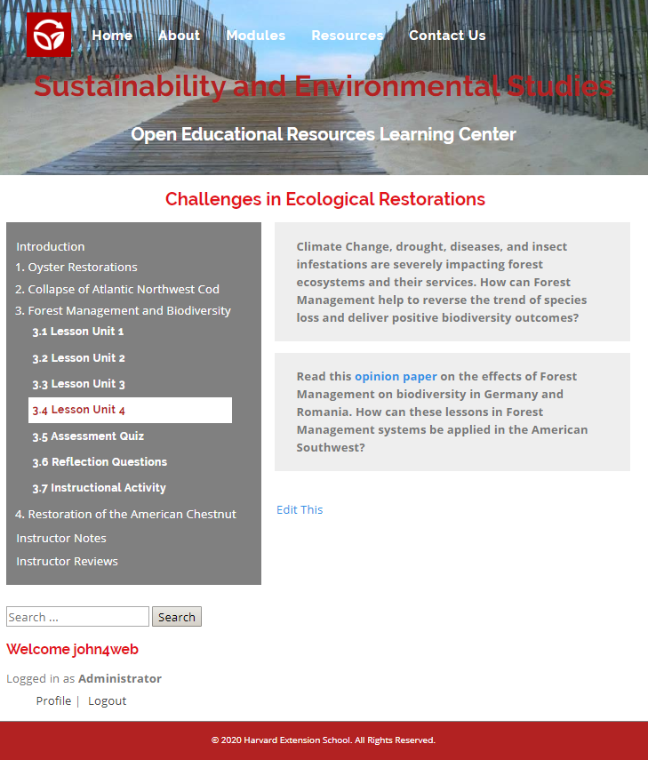

Finally, although the project focus was to curate a Learning Management System to supplement programs in Sustainability and Environmental Studies, the System itself should not be limited to that particular field of study. Rather, the LMS was developed so its capabilities are independent of the content. In this regard, the Capstone can be treated as a demonstration of the LMS for use in other educational and professional training applications.

**7. Demonstrative Product**

After presenting the lecture material, the instructor will assign the appropriate LMS lesson to complement the instruction. Each lesson is comprised of four lesson units, a short assessment quiz, two assessment questions and two instructional activities.

Using the Understanding by Design approach, each lesson unit presents the Big Idea which serves as the focus point for instruction and assessment.

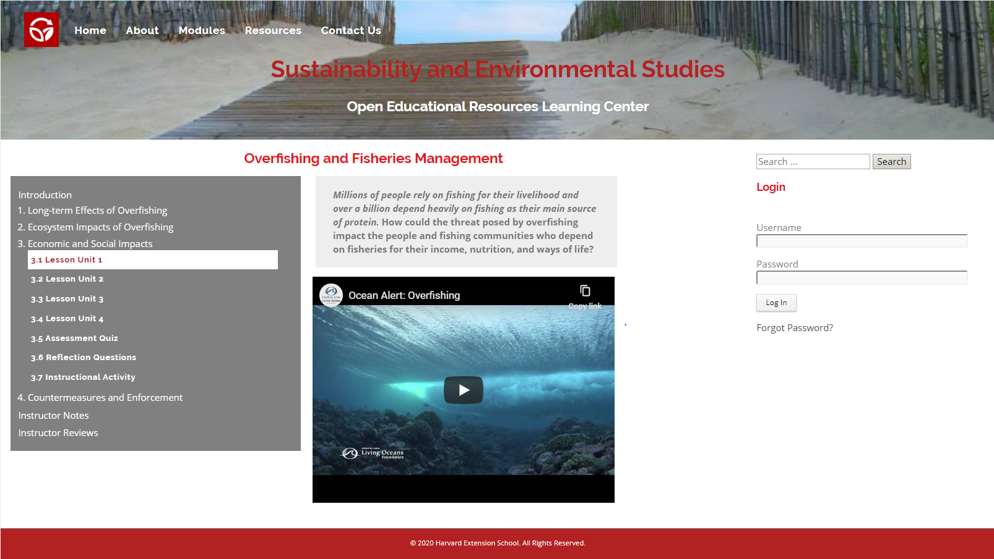

The lesson unit opens with a hook to capture the student’s attention.

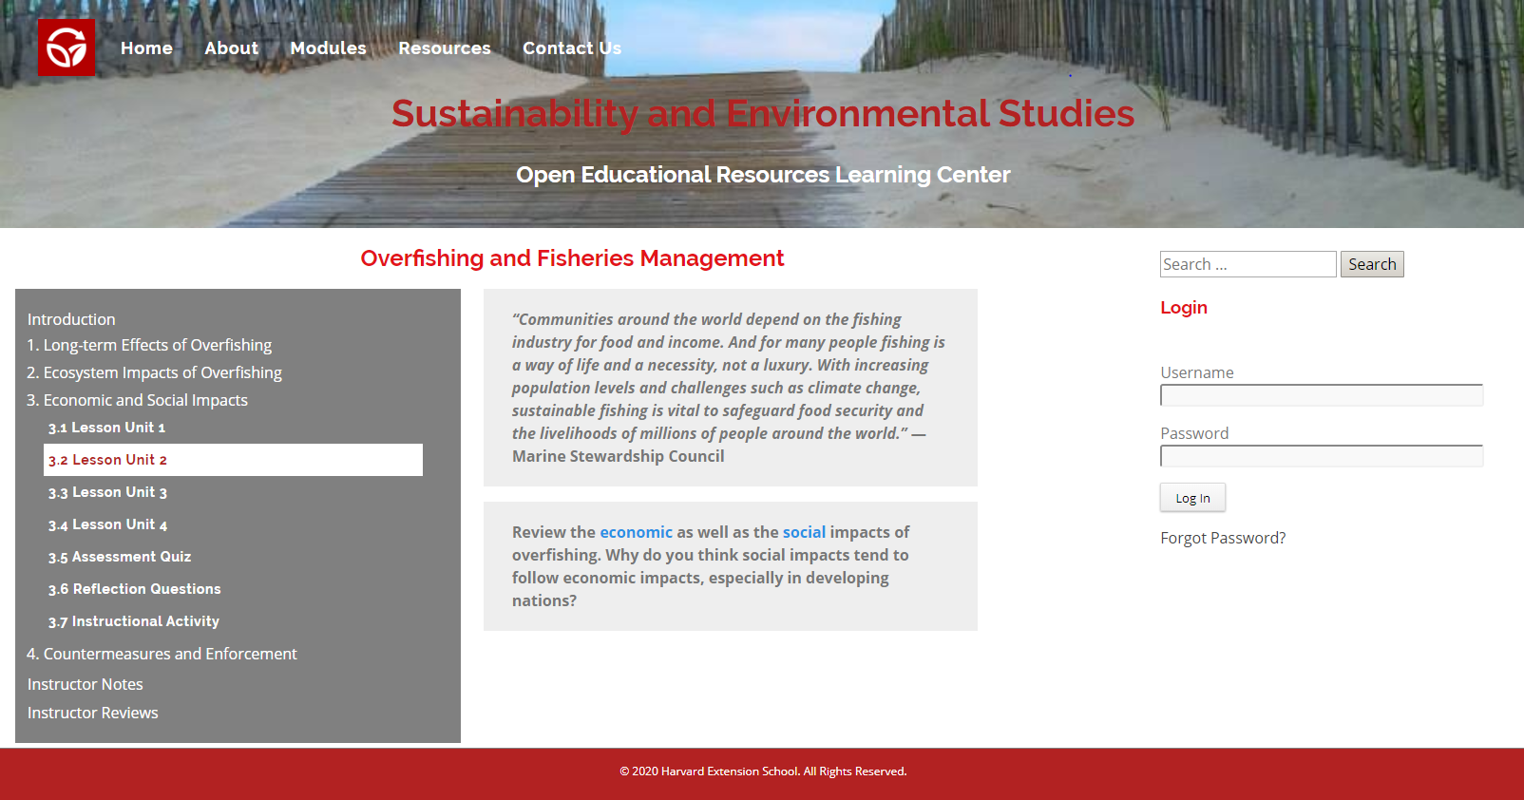

Since educational studies show that student’s attention significantly decreases after ten minutes, the lesson should take no more than ten minutes to complete.

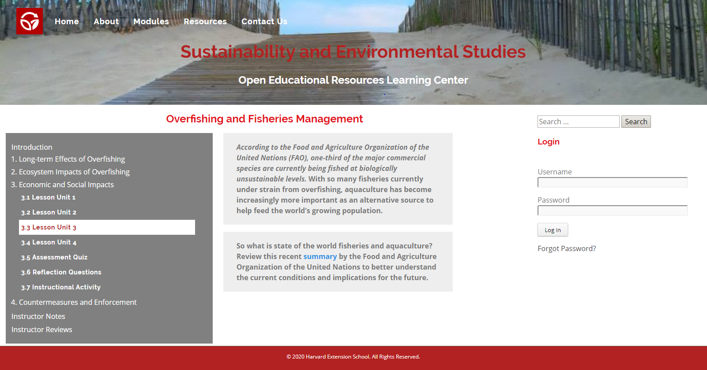

A variety of media content (videos, articles, papers and websites) is used to make lesson units more interesting and engaging.

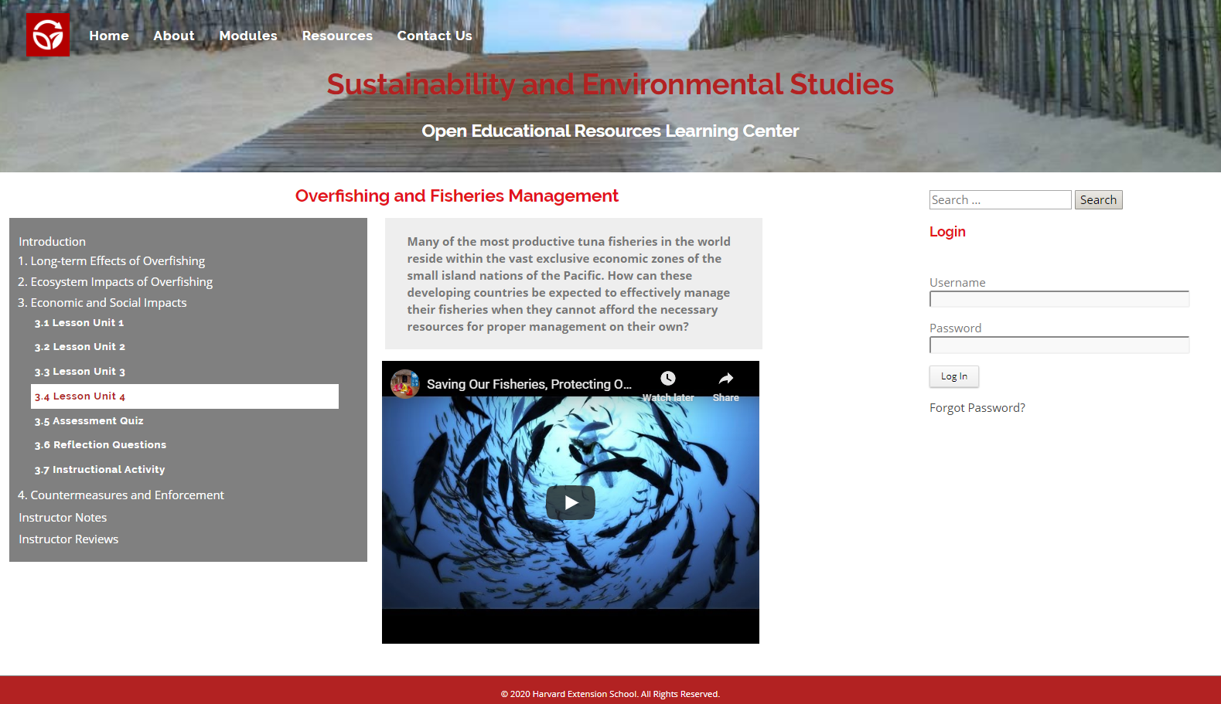

The Assessment Quiz is comprised of five essential questions as indicators of understanding as defined by the Six Facets of Understanding in the Understanding by Design approach.

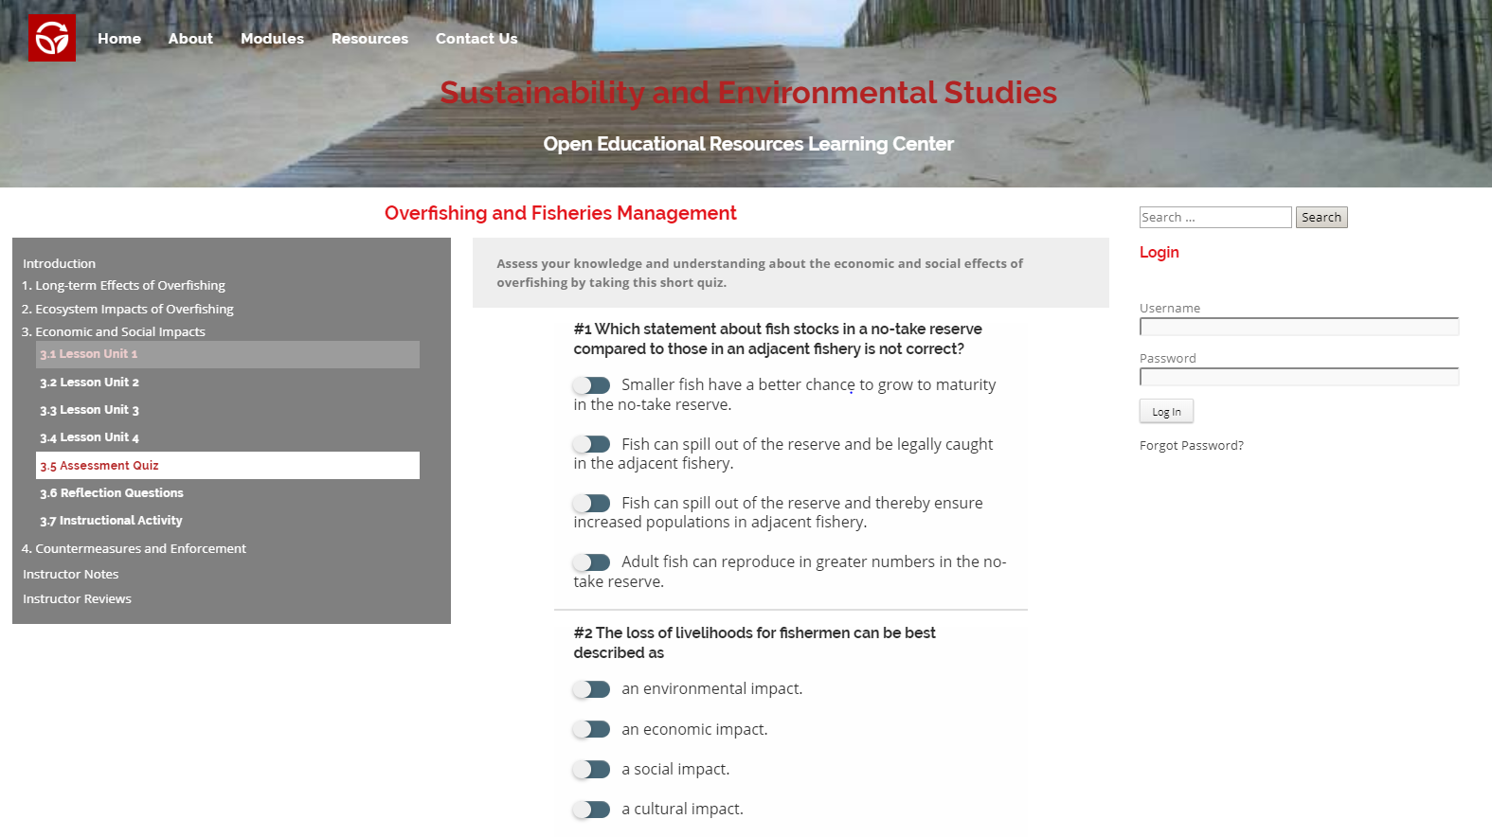

Reflection questions can be given as an individual or group assignment to assess understanding or can be discussed in class.

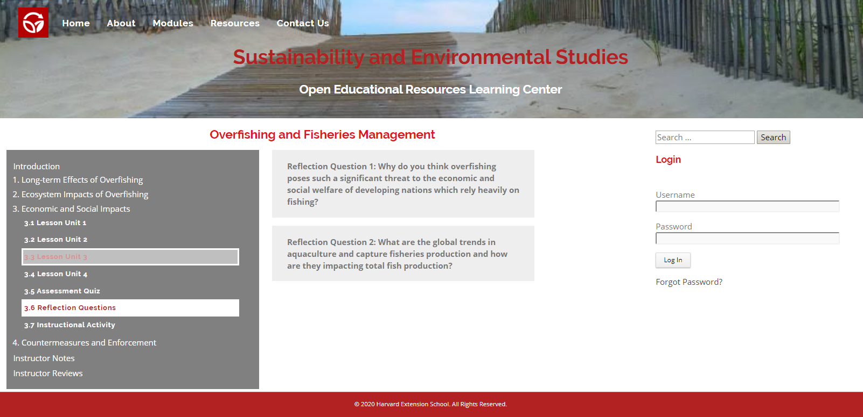

Students complete the instructional activities which are meant to reinforce student understanding of the lesson.

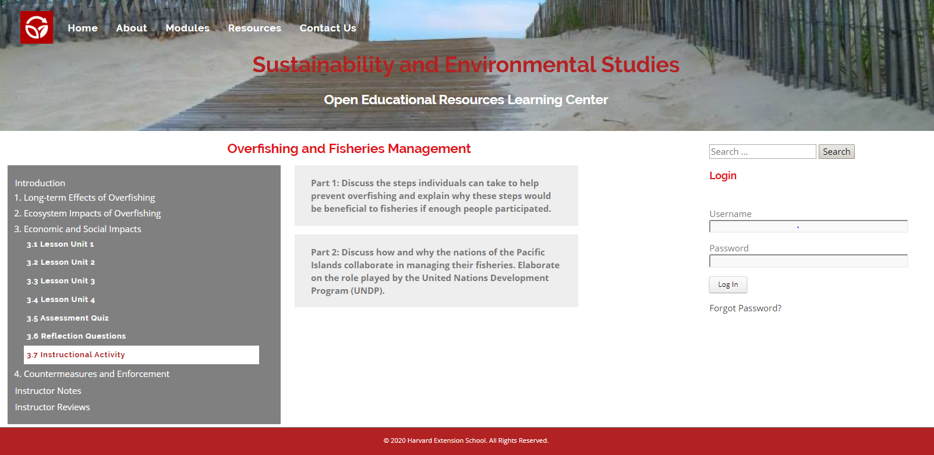

Instructors can supplement the lesson with their own curated content by posting to the Instructor Notes section.

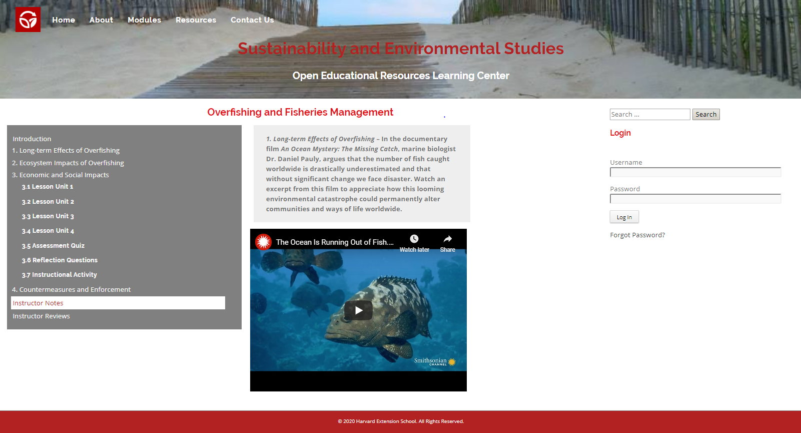

Finally, instructors can refine the lesson and understanding by posting to the Instructor Reviews section.

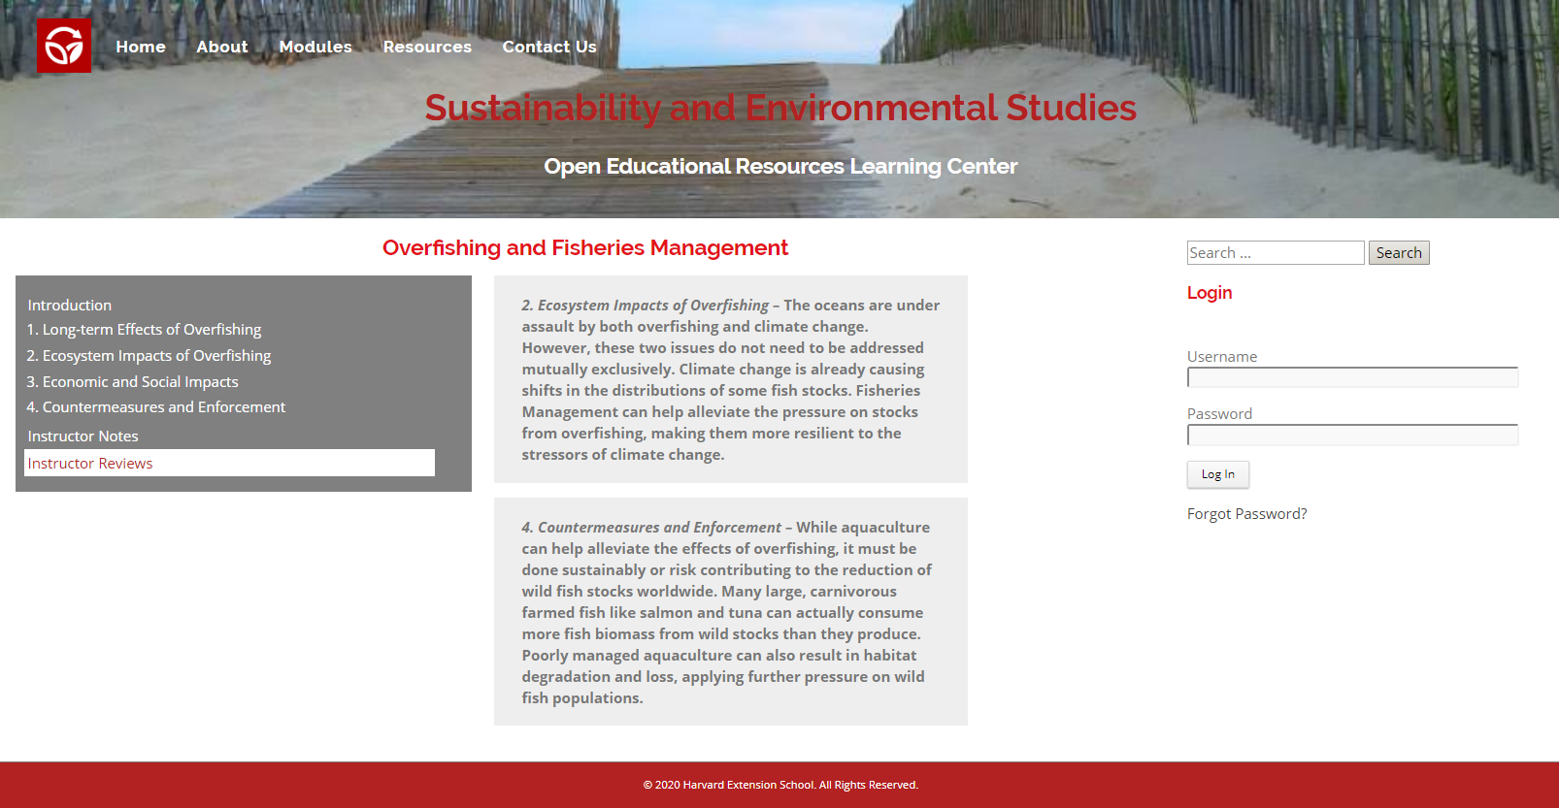

**8. Final Product**

I was able to curate the instruction content for this Capstone’s Learning Management System due to the knowledge and experienced gained by achieving my ALM degree in Sustainability and Environmental Studies from the Harvard Extension School in 2016. This content, though, would need to be tailored in order to the meet the course requirements of the instructors in actual implementation as a final production. Fortunately, the LMS was designed to make curating instructional content a simple and straightforward task.

**9. Summary and Conclusions**

Existing eLearning resources in Sustainability and Environmental Studies are limited and not very effective in that they are often too general and not focused on what environmental students need to learn in order to achieve the desired educational outcomes. However, the demand for these resources will continue to grow at a rapid pace as online education becomes more prevalent and mainstream. This Capstone’s Learning Management System, then, was specifically designed to address these issues by bridging this gap.

The instructional content in the LMS should complement instructor teachings by delving deeper into Sustainability and Environmental Studies topics and issues rather than cover introductory concepts or replace textbooks and lectures. To achieve this, the content used by the instructor needs to be tailored to the course requirements. Furthermore, effective eLearning resources need to deploy methods to capture and maintain student attention and to promote enduring understandings. This Capstone’s Learning Management System used the Understanding by Design approach to meet these educational requirements.

|  |
| --- |
| **Summary and Conclusions** |
| Existing eLearning resources are generally limited and not very effective. |
| Demand for online educational resources will continue to grow rapidly. |
| Instructional content in eLearning resources needs to complement instructor teachings. |
| Instructional content in eLearning resources needs to be tailored to the course requirements. |
| eLearning resources need to deploy methods to capture and maintain student attention. |
| eLearning resources need to deploy methods to promote enduring understandings. |

**10. Future Plans**

Notes to Write-up:

. Write up project for an educational publication.

. Look for Educational partner like Harvard Extension School to complete final production and launch the LMS.

. Does not need to be limited to Sustainability and Environmental Studies as can be tailored to practically any discipline.

**11. Project Repository**

The Learning Management System with all of the coding, data, and instructional content is directly hosted in WordPress in a siteground.com web account at<http://johnr1.sgedu.site/wp/>. The custom JavaScript coding, custom CSS styling, images, menus, and instructional content pdfs have been extracted to a GitHub repository at <https://github.com/jreillyHES/Capstone>.

**References**

Arshavskiy, M. (2014). Managing e-Learning Projects. *Elearning Industry*.

URL: <https://elearningindustry.com/managing-e-learning-projects>.

BBC. (2014). Your Guide to Environmental Studies Learning Resources and Online Courses. *BBC.*

URL: <http://www.bbc.co.uk/learning/subjects/environmental_studies.shtml>.

Bean, C. (2014). *The Accidental Instructional Designer: Learning Design for the Digital Age.*

Brandon, B. (2004). Closing the Loop in e-Learning Development: How to Reconnect Instructional Design and Project Management. *Learning Solutions Magazine*.

URL: <http://www.learningsolutionsmag.com/articles/283/closing-the-loop-in-e-learning-development-how-to-reconnect-instructional-design-and-project-management>.

Coursera. (2019). From Courses to Degrees. URL: <https://www.coursera.org/>.

CrystalBridges. (2017). Online Learning. Crystal Bridges Museum of American Art.

URL: <https://crystalbridges.org/online-learning/>

Growth Engineering. (2019). The Learning Portal – A Simple Idea that Made the World Better. URL: <https://www.growthengineering.co.uk/learning-portal/>.

Humboldt. (2019). Open Educational Resources (OER) Environment Science & Management, *Humboldt State University*.

URL: <https://libguides.humboldt.edu/openedu/emp>.

Khan Academy. (2019). Ecology.

URL: <https://www.khanacademy.org/science/biology/ecology>.

Rand-Hendriksen, M. (2019). WordPress 5 Essential Training. *Lynda.com*.

URL: <https://www.lynda.com/WordPress-tutorials/WordPress-5-Essential-Training/651229-2.html>.

Schaffhauser, D. (2014). 16 OER Sites Every Educator Should Know. *Campus Technology*.

URL: <https://campustechnology.com/articles/2014/07/02/16-oer-sites-every-educator-should-know.aspx>.

Schunn, C. (2008). Engineering Educational Design. *Journal of the International Society for Design and Development in Education.* Volume 1, Issue 1, Article 2. URL: <https://www.educationaldesigner.org/ed/volume1/issue1/article2/pdf/ed_1_1_schunn_08.pdf>.

Tutorspoint. (2019). Environmental Studies Tutorial.

URL: <https://www.tutorialspoint.com/environmental_studies/index.htm>.

Wiggins, G. and McTighe, J. (2005). *Understanding by Design.*